**Compilation of .XLS file after CDOM lab measurements   
(updated CDOM measurements starting from fall 2017)**

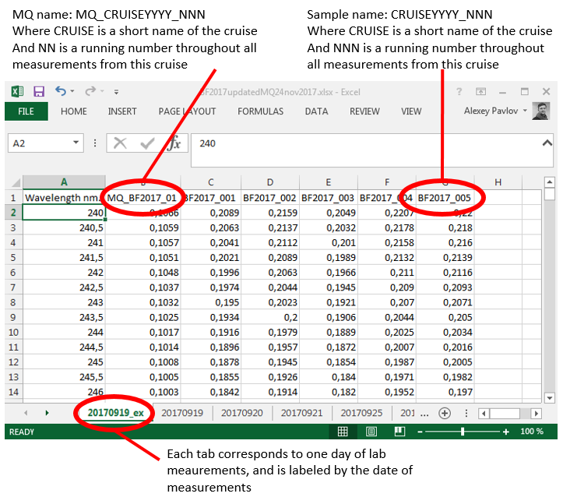

**Processing of data in R**

1. **Read in data**
2. **Subtraction of MQ**

Done within data of one XLS tab. One MQ is subtracted from all spectra in the tab.

1. **Baseline correction**

Subtract average absorption in the range 600-650 nm from each spectra

1. **Standard conversion from absorbance to absorption coefficients**
2. **Extract absorption values at certain wavelengths**

254, 350, 375, 440 nm

1. **Calculate spectral slopes for 275-295 and 350-400 nm**

Assuming absorption values between 275 and 400 nm are positive, log transform data and estimate slopes for two ranges 275-295 and 350-400 nm. If values are negative within 350-400 nm, slope is not calculated and the spectrum is flagged. Calculate slopes ratio (Sr) as S275-295 devided by S350-400.

1. **Calculate spectral slopes for 300-650 nm**

Apply non-linear fit with equation (below) containing three constants: acdom(λ0), S, K and λ0 = 350 nm.



1. **Save / export variables**

Absorption at 254, 350, 375, 440, 443 nm  
Slopes: 275-295, 350-400, 300-650 nm  
Slope ratio: Sr  
Flag  
Processed data (after step 4 above)